39.55: 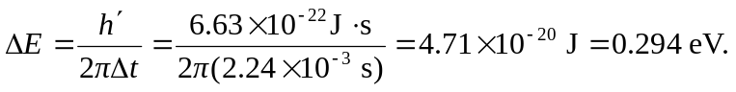
Note that this uncertainty is much larger than the real uncertainty as compared to the
4.50 eV.

